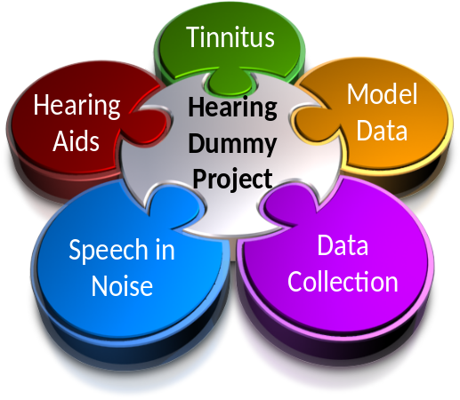

Essex Hearing Dummy Project

Auditory profiles

(January 2012)

Prof. Ray Meddis
Dr. Wendy Lecluyse
Dr. Christine Tan
Dr. Nick Clark
Dr. Tim Juergens

Table of contents

Introduction 3
The measurement of auditory profiles 4
IFMC ‘depth’ measure 5
TMC slope measure 5
Database summary 12
Average profiles 13
Statistical analyses 16
Comparing good and impaired hearing statistics 17
Raw profiles (Normal) 19
Raw profiles (impaired) 33
Double profiles 66
File format and programs 74

Introduction
The Hearing Laboratory at Essex has accumulated a useful number of auditory profiles for a range of people with good hearing or sensorineural hearing impairment. These profiles were collected using the multiThreshold software. This document describes how to access these profiles. The data were collected by Dr Wendy Lecluyse and Dr Christine Tan as part of their doctoral studies. Dr. Tan transcribed the data from the individual participant records to a more standard format using MATLAB .m files.
The profiles were collected from individuals with a sensorineural hearing loss (average age 59 years) as well as some young adults with good hearing (average age 32 years). Both groups consist of unpaid volunteers. Altogether, there are 77 participants; 23 with good hearing and 54 with impaired hearing. The average ages (with standard deviations) are, respectively, 32 (10) and 59 (11) years. The male/female ratio is approximately 3:2 in both cases.
The profiles and participant information are held in a profiles folder in the MAP1_14 software package. A readable representation of all the profiles, each presented as a separate chart can be found in a WORD document, Profiles summary.doc.This document also contains some statistical analysis. For many, this will be all that is required to become familiar with the dataset. However, for those who wish to investigate the profiles in greater detail an appendix is supplied, describing the programs used to organise and analyse the data.

The measurement of auditory profiles
An auditory profile summarises the data generated using three tests measuring absolute threshold, frequency-selectivity and compression. A detailed account of the procedures is given below. The data for a single individual is combined to generate a graphical representation called an auditory profile. This section offers a detailed guide to these profiles
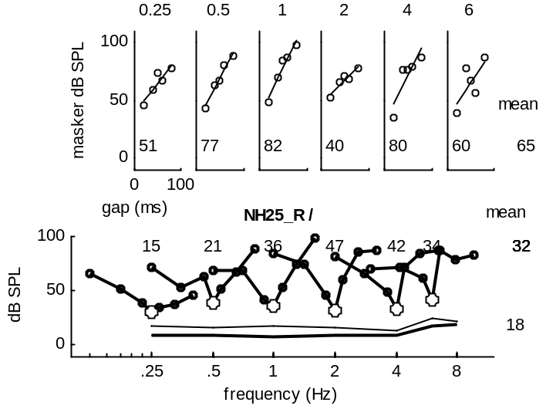
This profile was collected from one of the authors with good hearing. All levels are dB SPL.
The top row shows the temporal masking curve (TMC) measured at a number of different probe frequencies. The probe frequency is indicated at the top of each panel. The slope of the TMC is supposed to be an indication of compression (steeper slopes, more compression). The original data points are the unfilled circles. The line is the best-fit straight line. The slope of the line is printed at the bottom of the panel in terms of the dB increase in the masker level per 100-ms increase in the gap between the masker and probe. The average slope across all frequencies is given to the right.
The bottom panel shows the V-shaped frequency-selectivity curves for probes of different frequencies. These are iso-forward-masking contours (IFMCs). The probe frequency (fp) is indicated by the unfilled circles along the function. However the points along the function are the masker levels at different frequencies. The ‘depth’ of the V is posted at the top of the panel above the corresponding function. It represents the difference between the level of the masker at fp and the average of masker levels at 0.7*fp and 1.3*fp. The mean depth across all frequencies is shown to the right.
The lines at the bottom of the panel show the absolute thresholds for a 16-ms probe and (below it) the absolute threshold for a 250-ms probe at frequencies 250, 500, 1000, 2000, 4000 and 8000. The mean absolute threshold is shown to the right.

IFMC ‘depth’ measure
The depth measure is defined as ‘the difference between the level of the masker at fp and the average of masker levels at 0.7*fp and 1.3*fp’ and is illustrated below. Clearly, this statistic will be large when the arms of the V-shape are steep and when the V is symmetric. Any deviation from this pattern will reduce the depth estimate and even render it negative.

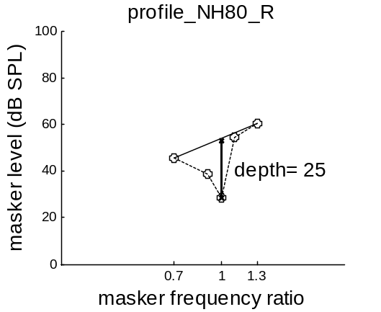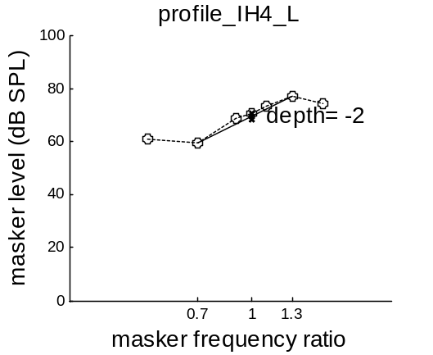

TMC slope measure
The slope is simply the slope of the least-squares best-fit straight line. In almost all cases, this is a good fit.
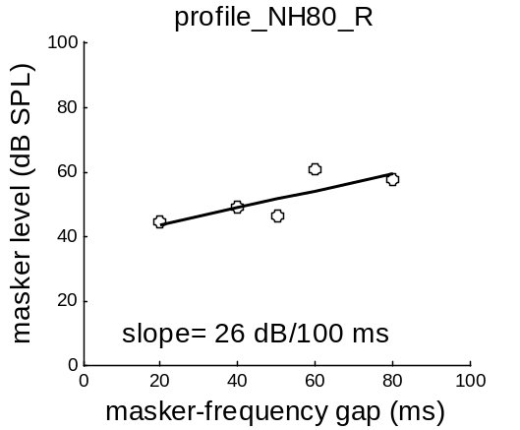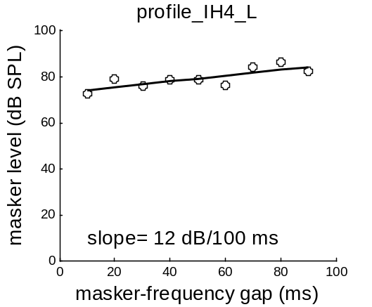
Occasionally the line has a distinct bend which may indicate a real change in the underlying function. This may indicate a change from a linear to a compressed region. In these rare cases the slope is an underestimate of the compressed portion of the line.
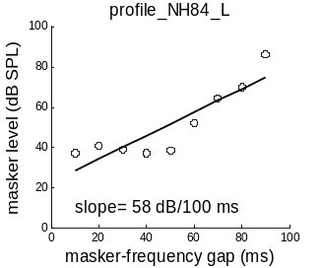

Equipment
Absolute threshold, frequency selectivity and compression tests were carried out in a sound-proof booth. Stimuli were presented through circumaural headphones (Sennheiser HD600) linked directly to a computer sound card (Audiophile 2496, 24-bit, 96000-Hz sampling rate). The procedures were automated using a computer program written in the MATLAB computer language. This program is available from the authors on request. Participants were equipped with a small console with 4 buttons. A computer monitor in front of the participant showed a graphical user interface display of the button console. While the stimulus was presented the button symbols on the display disappeared. Immediately after stimulus presentation the buttons reappeared on the screen signalling that a response was required.

Procedure and stimuli
All stimuli used pure tones, ramped with raised cosine onset and offset times of 4 ms. Schematic representations of the stimuli and the resulting thresholds are shown in Fig. 1. All stimuli (tone alone or masker-probe tone combinations) were preceded by cue stimuli that were identical to the test stimuli in all respects except for a single difference arranged so that the target tone was always more audible in the cue stimulus. For absolute threshold measurements, the cue tone was always 10 dB more intense than the test tone (Fig 1A). For frequency selectivity and compression measures, the cue masker was always 10 dB less intense than the test masker (Fig 1B and C). The cue-test stimulus interval was 500 ms.
Absolute thresholds were measured using 250-ms pure tones (Fig. 1A) at frequencies (f_{t}) 250, 500, 1000, 2000, 4000 and 8000 Hz.
Frequency selectivity was assessed using forward masking. The patient’s task was to report the presence or absence of a probe tone following a masking tone. Each measurement was a masking threshold, the masker level required to just mask the probe tone. Masking thresholds were measured at 7 different masker frequencies (f_{m}) specified relative to the probe frequency (0.5, 0.7, 0.9, 1, 1.1, 1.3, and 1.6 * f_{t}) to generate an Iso-Forward Masking Contour (IFMC). IFMCs were determined for a range of probe frequencies (f_{t}), 500, 1000, 2000, 4000 and 6000 Hz. Masker and probe durations (D_{m}, D_{t}) were 108 ms and 16 ms respectively. For each probe frequency the absolute threshold for the 16-ms probe tone needed to be determined. Subsequently this threshold was used to fix the level of the probe in the forward masking task. Here the probe tone was always presented at 10 dB above its threshold. The gap duration between masker and probe was set at 10 ms. A schematic representation of the stimulus and an example of a 2000-Hz IFMC are shown in Fig. 1B.
Compression was also assessed forward masking. Similar to the IFMC, the patient’s task was to report the presence or absence of a probe tone following a masking tone. Each measurement comprised of a masking threshold. Masking thresholds were measured at 5 different gap durations (20, 40, 50, 60 and 80 ms) to generate a Temporal Masking Curve (TMC). Gap duration was defined as the duration of the silence period between the masker offset and the probe onset. TMCs were obtained for probe frequencies (f_{t}) of 500, 1000, 2000, 4000 and 6000 Hz. Masker frequency (f_{m}) was set equal to the probe frequency. Masker and probe durations were 108 ms and 16 ms respectively. For all conditions, the probe level was fixed at 10 dB above its own threshold. A schematic representation of the stimulus and an example of a TMC are shown in Fig. 1C.
The main difference in the protocol described above with the longer, initial protocol (phase I) is that each data point was the result of a single measurement. In phase I, data points were generally the average of 3 measurements. Some smaller, less important changes were adjustments of the tone duration for the absolute thresholds (250 ms instead of 500 ms) and adjustment of the probe duration in the forward masking tasks (16 ms instead of 8 ms). The latter adjustment increased the ease of the forward masking task. Finally, the Phase I TMC consisted of 9 data points (10-90 ms gaps in 10-ms intervals) instead of the 5 data points used in later tests. Rather than omit these additional points in the interests of consistency, these data points were retained in the profiles to be presented.
Pure-tone Audiometry was conducted using standard protocols (BSA 2004). Audiometric thresholds were measured at 250, 500, 1000, 2000, 4000 and 8000 Hz.

Threshold estimation procedure
The basic procedure for measuring absolute and masking thresholds was based on an adaptive yes-no paradigm (Bekesy 1947, Dixon & Mood 1948, Carhart & Jerger 1959, Cornsweet 1962, Leek et al. 2000). This single-interval up/down procedure (SIUD), was based on modifications previously proposed and evaluated by Lecluyse and Meddis (2009).
A test stimulus was presented to the participant whose response was interpreted as ‘yes’ or ‘no’, i.e. whether or not the test tone was heard. A level adjustment was applied from trial to trial using a one-down, one-up adaptive procedure. The direction of the adjustment depended on the task participants were asked to perform. When measuring absolute threshold, the stimulus level was increased by a fixed amount if the response was a ‘no’. If the response was a ‘yes’, the level was decreased by the same amount. In the forward masking tasks the masker level was increased when the test probe was detected and decreased when no test probe was heard. By presenting a cue stimulus before the test stimulus, this task now became a counting task, with the listener indicating ‘how many’ tones were heard. A ‘2’ response indicated that both the cue and the test stimulus had been heard, equivalent to a ‘yes’ response. A ‘1’ response meant only the easier-to-hear cue was perceived and corresponded to a ‘no’ response.
The threshold run started with an initial phase where the stimulus level was set at a level generating a guaranteed ‘yes’-response and was adjusted using a 10-dB step size until the first ‘no’-response. After the first ‘no’ response, the stimulus level was set to the mid-point between the previous two levels and a smaller, 2-dB, step size was used thereafter. The run then continued for 10 trials counting from the trial immediately before the first ‘no’ response.

 | Cue + test stimulus | Data (schematic)
A.  Absolute threshold | 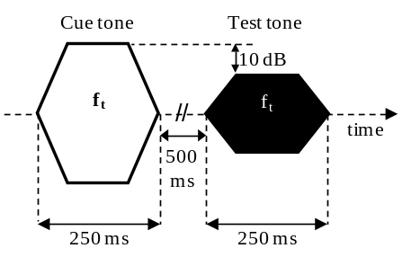 | 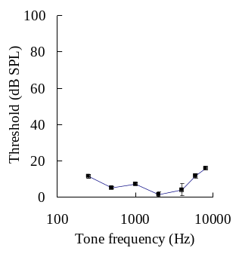
B. IFMC | 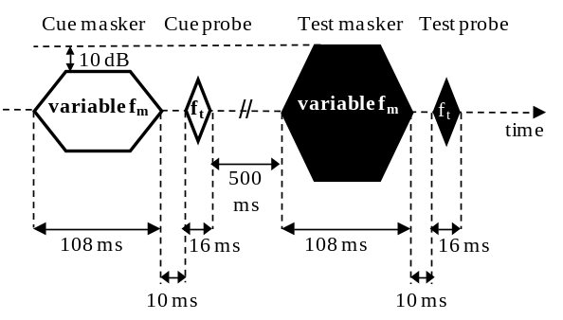 | 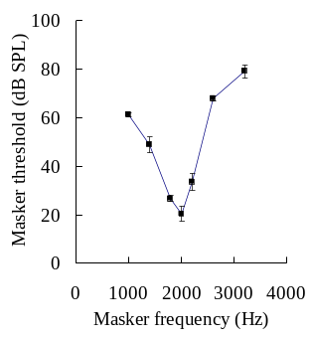
C. TMC | 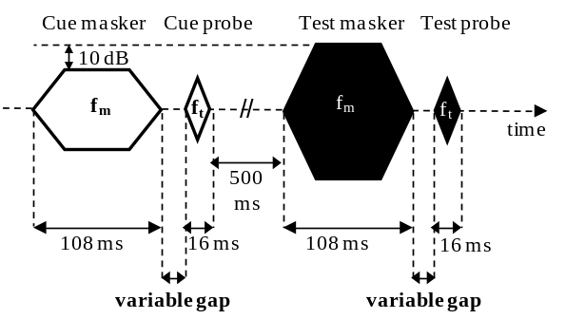 | 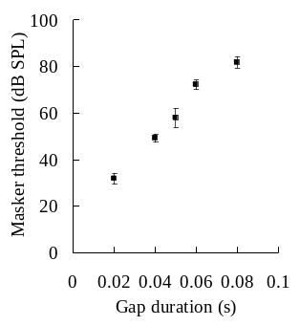

The start level of the stimulus was different in each run and randomly located in a range ±5 dB relative to the nominal start value. For the forward masking measures (IFMC and TMC) the start value of the masker was set at a low level such that only the probe tones were heard. This ensured that the listener was reminded what the probe tone sounded like and where in time it would occur.
The threshold was estimated at the end of the run. All stimulus levels from the trial before the first reversal onwards were included in the estimate of the threshold. Earlier trials were discarded. The threshold was estimated by fitting a psychometric function of the form p(L)= 1/(1+exp(-k(L-θ))), where p is a binary vector of the yes/no responses, L is a vector of the levels (dB SPL) associated with the response vector, k is a slope parameter and θ (dB SPL) is the threshold to be estimated. The threshold, θ, is the level of the stimulus at which the proportion of yes-responses is expected to be 0.5. The psychometric function was fitted to the responses using a least-squares, best-fit procedure, with θ and k as free parameters.
Catch trials. One in five trials were ‘catch trials’ where the cue tone was retained but the test tone was omitted. In this case a ‘0’ or a ‘1’ response was treated as correct but a ‘2’ response was incorrect (false-positive). This was taken to indicate that the listener was not attending or was using an inappropriate strategy. If the participant produces a false-positive, the run was stopped and restarted; possibly after resting the participant and giving further instructions. Participants are encouraged not to guess but to report hearing a (possibly very faint) test tone only when they are confident that they have heard it. The restart process following the false-positives acts as an additional incentive for patients to make only confident judgments. A catch trial was always presented on the 2nd trial in a run to remind the listener of what a ‘no-stimulus’ sounds like. Catch trials are not included in the trial count.

Instruction and training
The instructions given to the listener need to be carefully worded and can be found in appendix A. Experienced experimenters have been able to generate reliable data very quickly (see below). However an element of skill might be involved in instructing the participants. Therefore a clear set of written instructions was assembled and this was found to enhance reliability.
Pilot experiments (not shown) investigating the training effects in the SIUD-procedure showed that a single run in the absolute threshold task was sufficient to provide stable threshold estimates. Similarly, stable masking thresholds were obtained after only 4 threshold runs. Therefore no formal training session took place. Participants received instructions on the absolute threshold task and had a trial run which familiarized them with the testing procedure. If necessary, this was repeated until the participant felt confident about the task at hand. Data collection always started with the absolute threshold measurements. A similar process was followed for the forward masking task. The forward masking task was always introduced in the context of the IFMC measures. Again, the participant was instructed on the task and subsequently performed a trial run. A number of points on the IFMC were found to be more suitable as training conditions such as the condition with masker frequency = 0.5 * probe frequency. The substantial ‘distance’ in frequency between the masker and the probe tone improves the contrast between the 2 stimuli and facilitates the decision concerning the presence or absence of the probe tone in the presence of the masker. Once the participant was confident about the forward-masking task, data collection continued. TMC measurements were always the last section conducted in the protocol.

Database summary

Participant summary

number of participants = 103
number of impaired /normal hearing used= 65 / 25

number of males /females = 56 / 34
number of impaired males /females = 41 / 24
number of normal males/females = 15 / 10
average age impaired/ normal = 59.2 (11.0) / 32.3 (9.8 )

impaired with tinnitus yes/no/not determined = 44 / 19 / 2
normal with tinnitus yes/no/not determined = 3 / 22 / 0

117 ears measured
89 impaired ears measured
28 good ears measured
impaired right ear/ left ear = 47 / 42
normal right ear/ left ear = 19 / 9

Average profiles

Profiles were averaged across listeners as follows
The average absolute thresholds were simple averages across subjects.
The average TMCs were simple averages across subjects.
The average IFMC was obtained by first expressing all levels relative to the masker level at the probe frequency, averaging and then adding back the average threshold at the probe frequency.
Normal
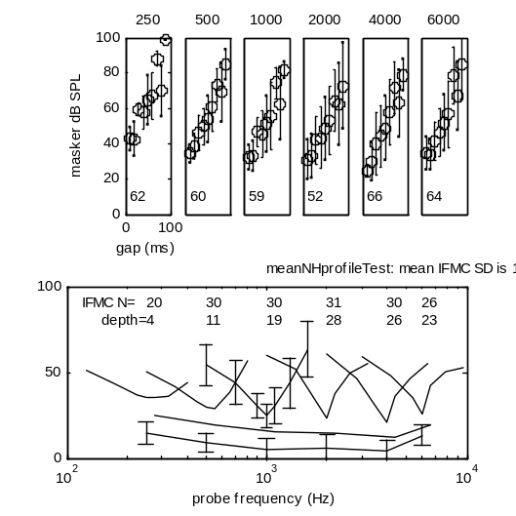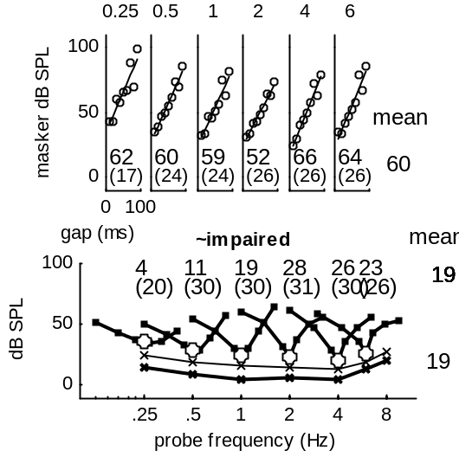

Impaired
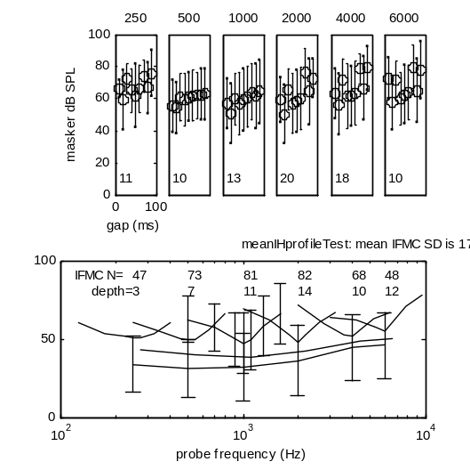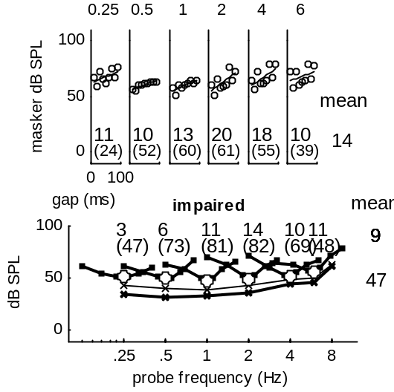

With tinnitus without
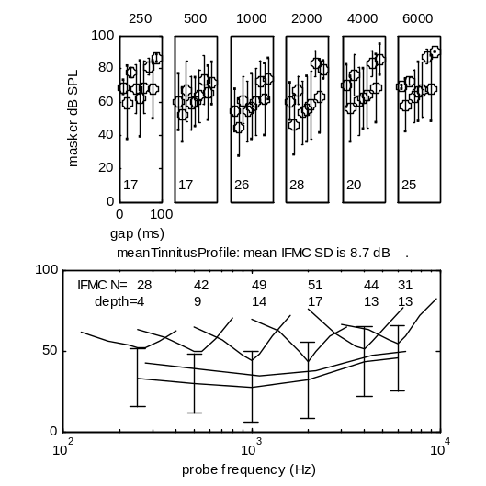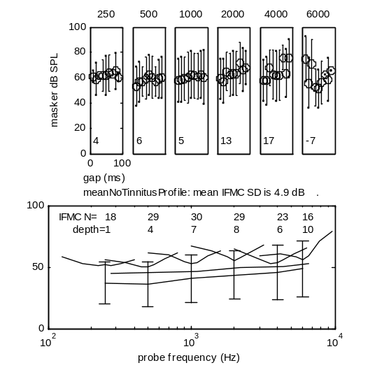
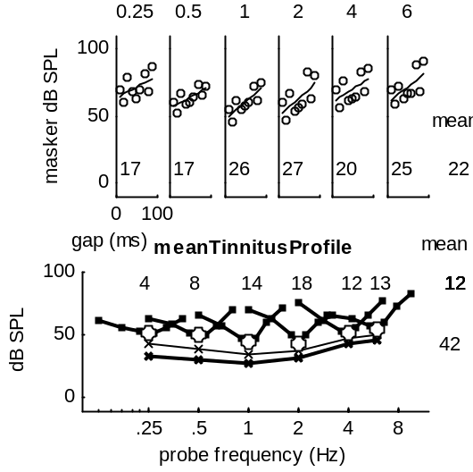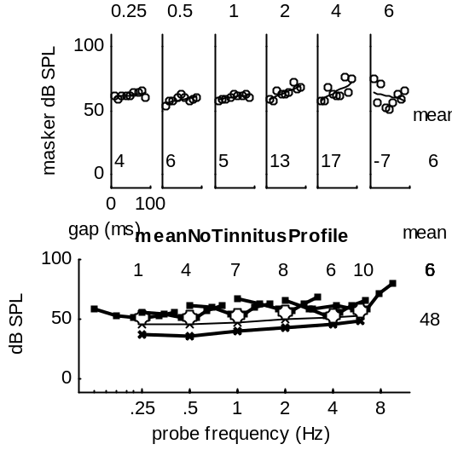

Statistical analyses

Comparing good and impaired hearing statistics
This figure shows the average thresholds, slopes and frequency-selectivity depth for two sets of profiles (good hearing and impaired hearing) at a range of different frequencies.

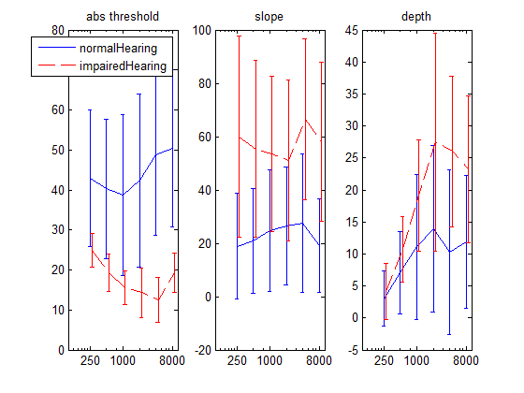
After removing NH with low-level linearity: 5,6,8,16,22,23
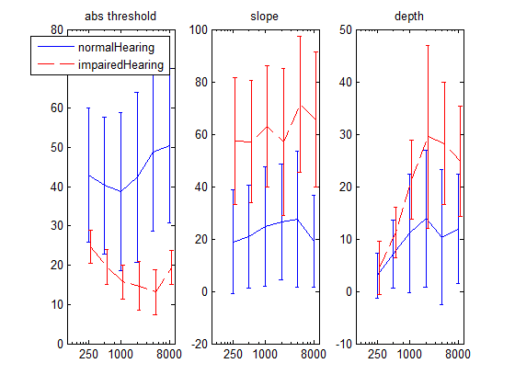

The histograms in the figures that follow show the distribution of threshold, slope and depth measures for the two groups separately.
The scatter plots show the correlations among the three measurements, again computed separately for the two groups and for six probe frequencies
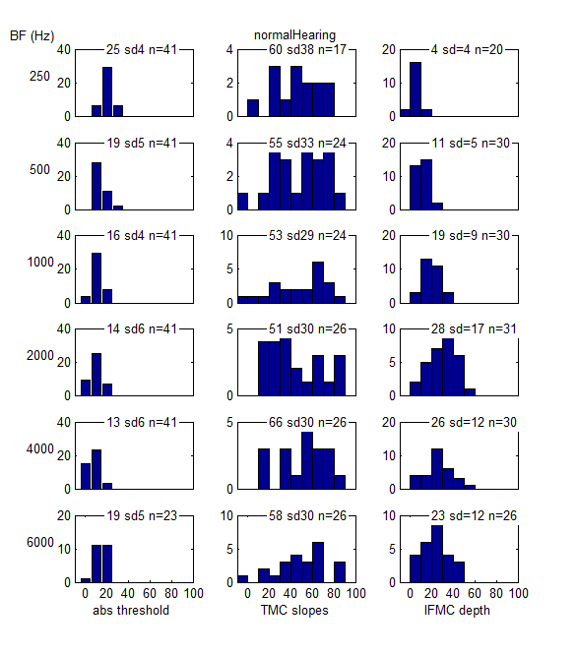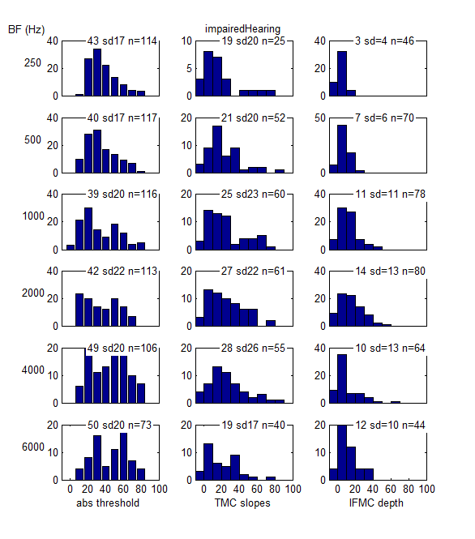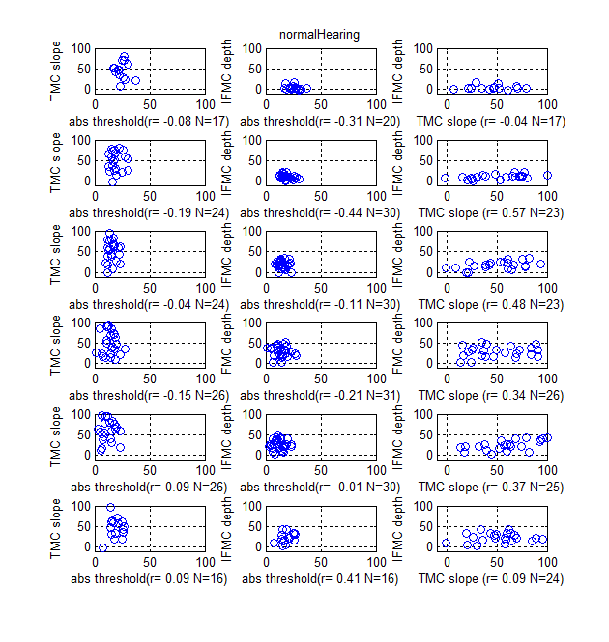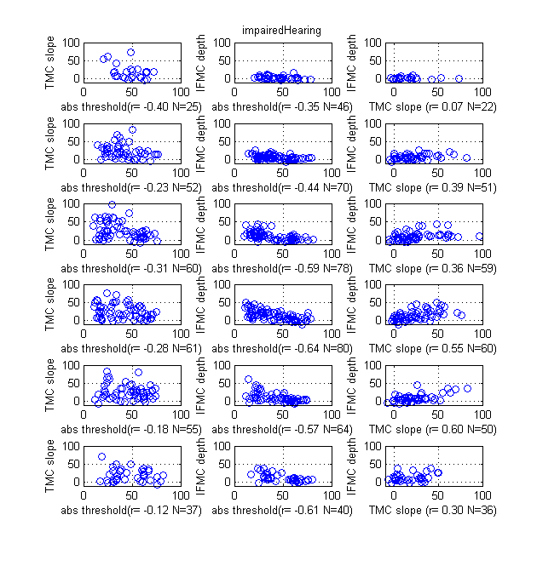

Raw profiles (Normal)

All profiles are shown.
When only one ear was tested the other ear is left blank.
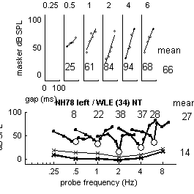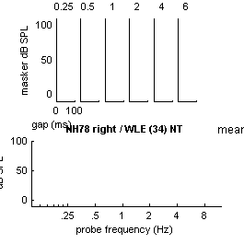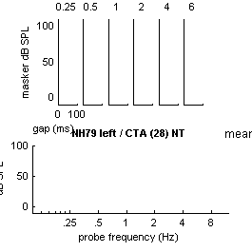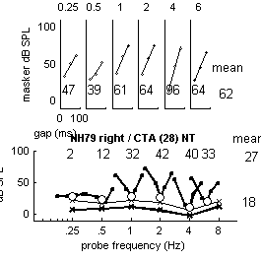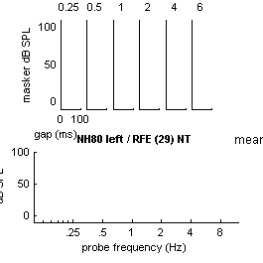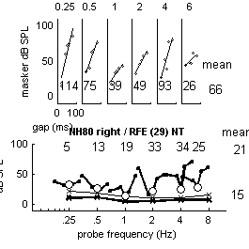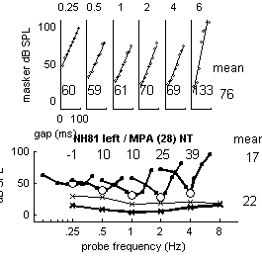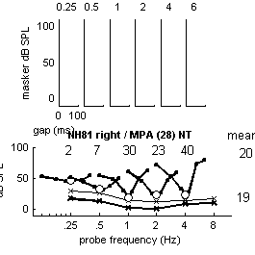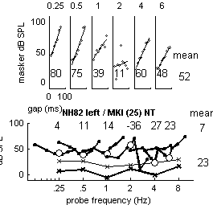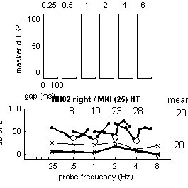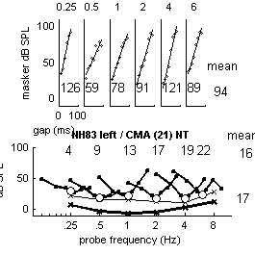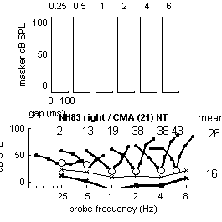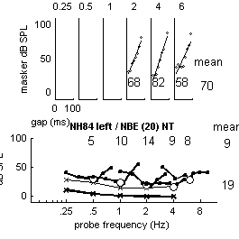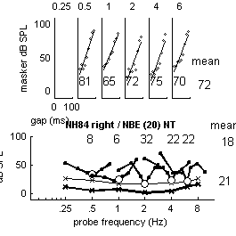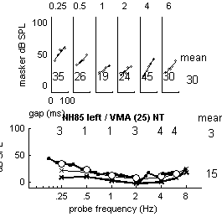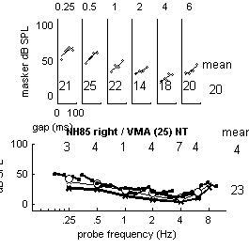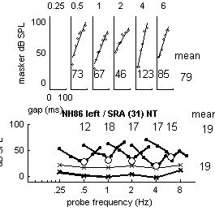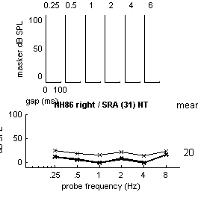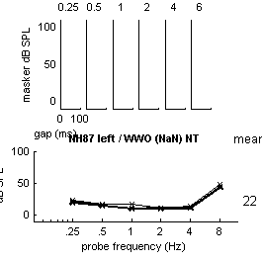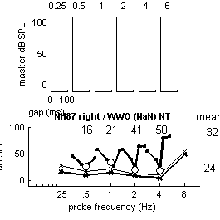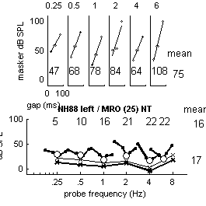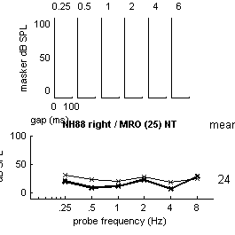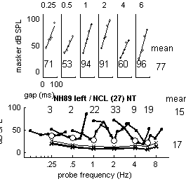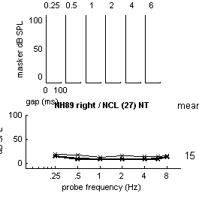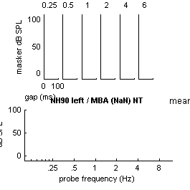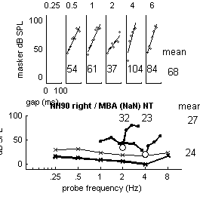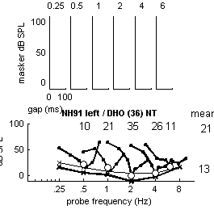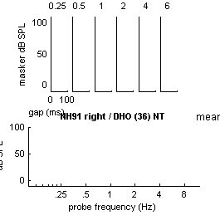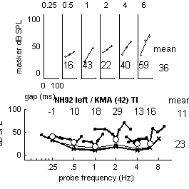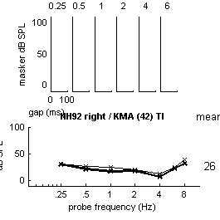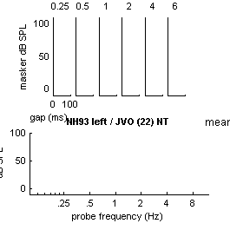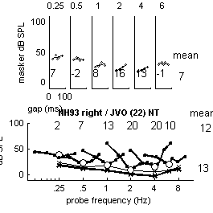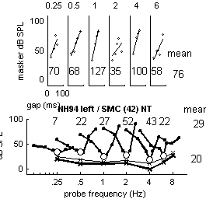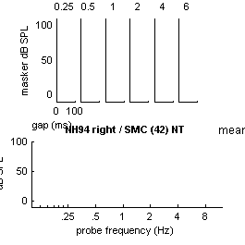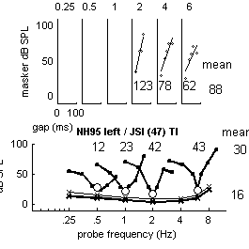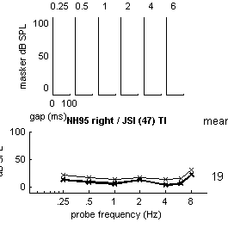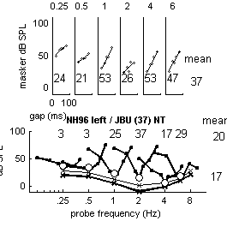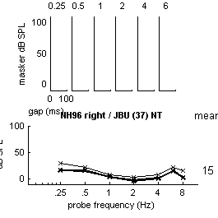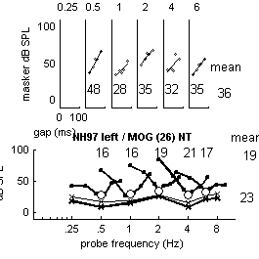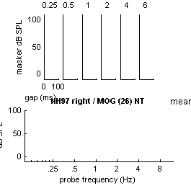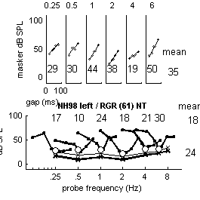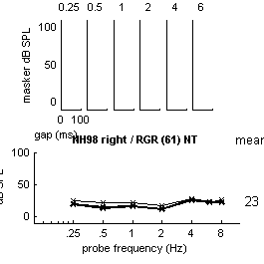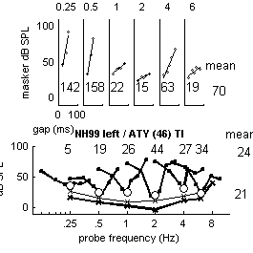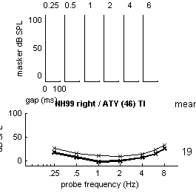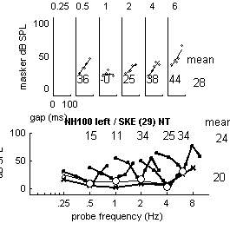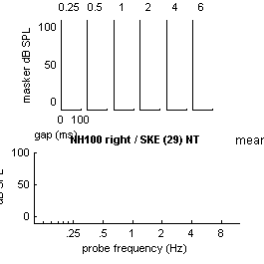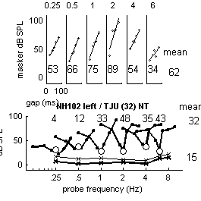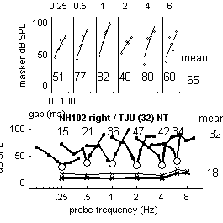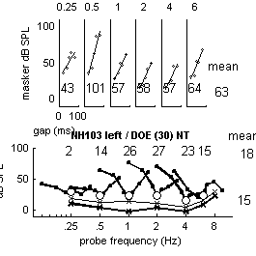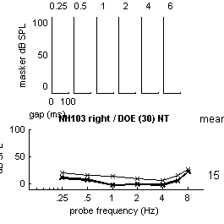analyse accumulated data for this group & display average25participants
SS = IFMCsampleSize: [20 30 30 31 30 26 11]
absThrSampleSize: [41 41 41 41 41 23 40]
TMCsampleSize: [17 24 24 26 26 26 5]
meanLongTones: [14.5715 8.9344 5.1632 5.6451 4.2698 13.4435 20.0733]
meanShortTones: [1x7 double]
stdevLongTones: [6.1229 5.3700 6.6323 8.0837 6.3709 5.9082 10.5285]
stdevShortTones: [4.3140 4.6605 4.2868 6.2639 5.5783 5.0014 8.7179]
stdevIFMCs: [7x7 double]
+ stdevTMCs: [7x9 double]mean short vs long= 250 10.4 500 10.31000 10.42000 8.74000 8.36000 5.88000
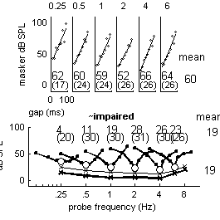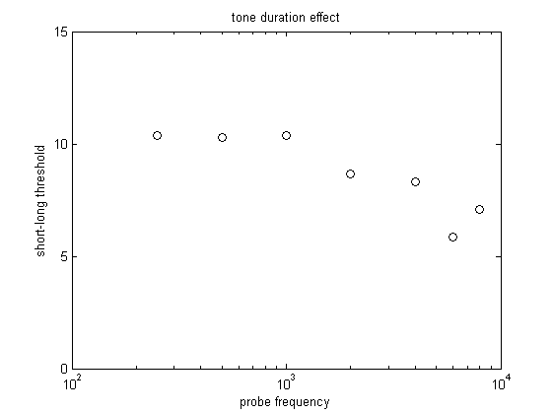
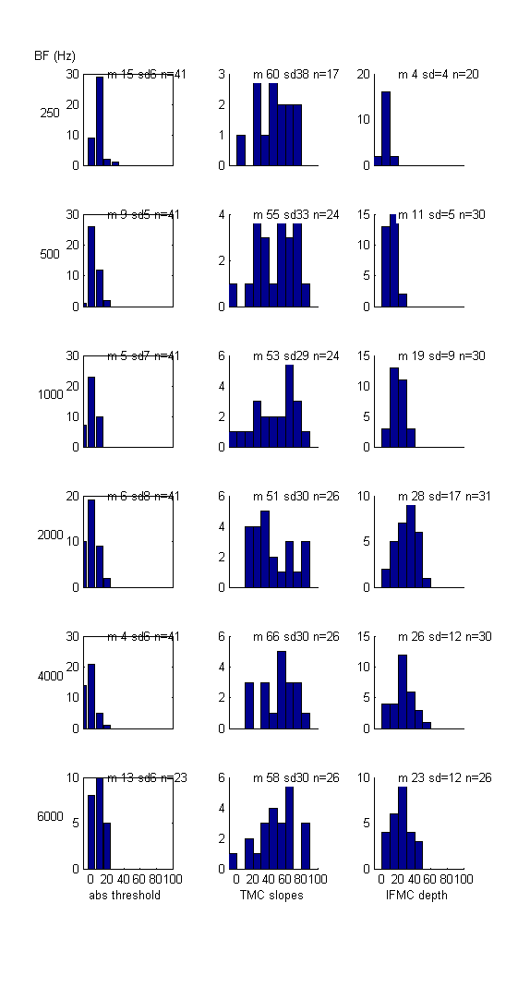hist 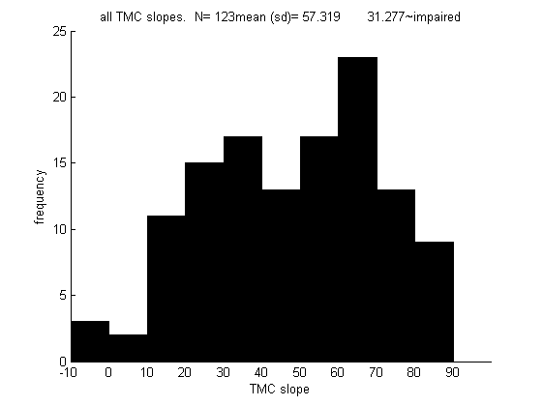

Compare left and right ears
mean abs threshold difference= 0.46571 logical requ
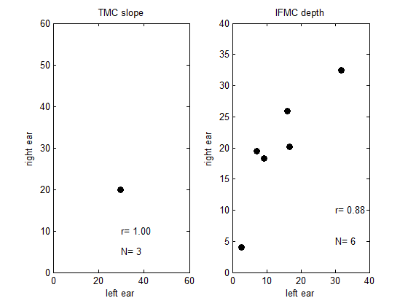

Raw profiles (impaired)

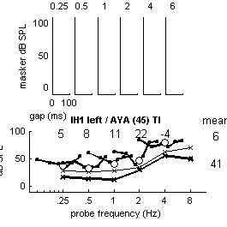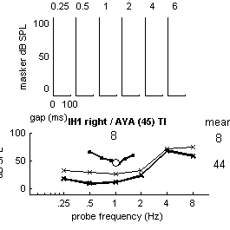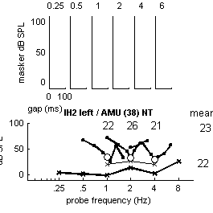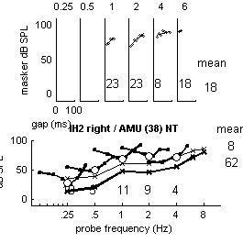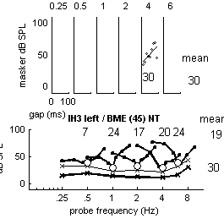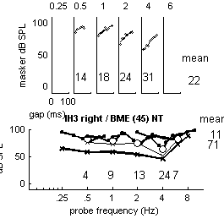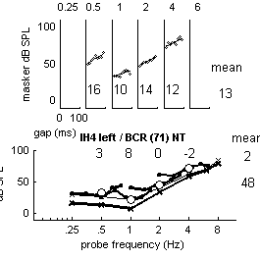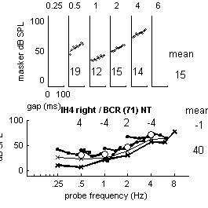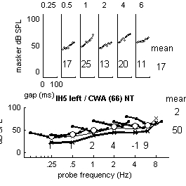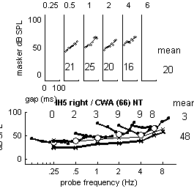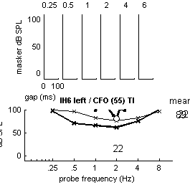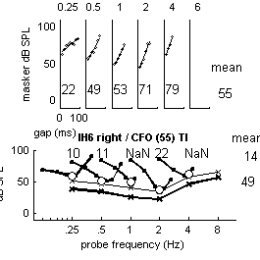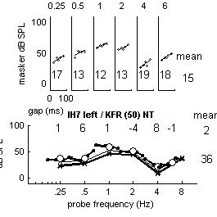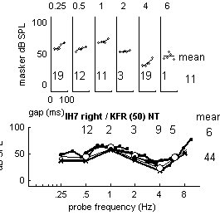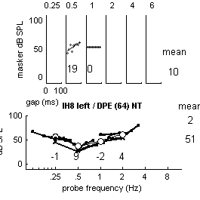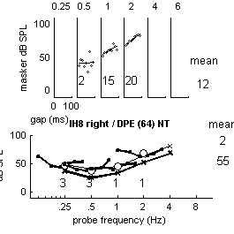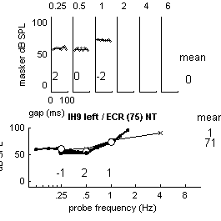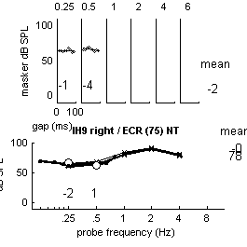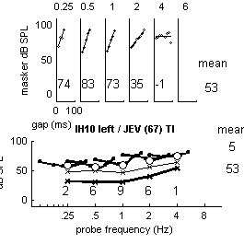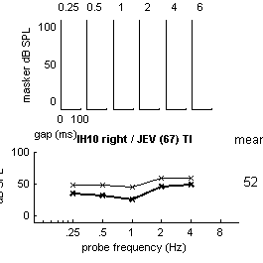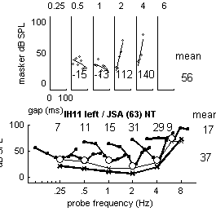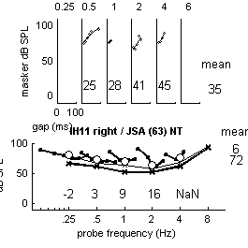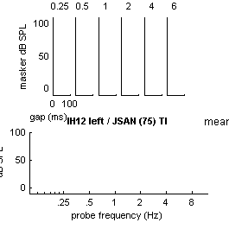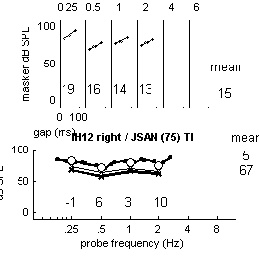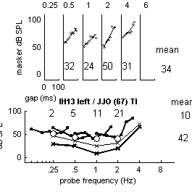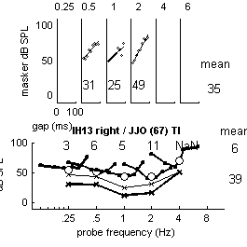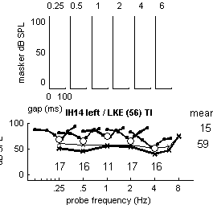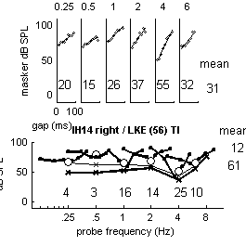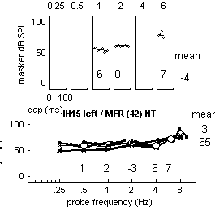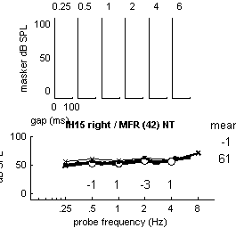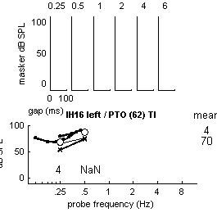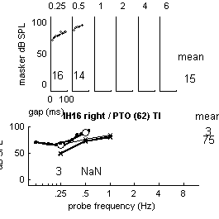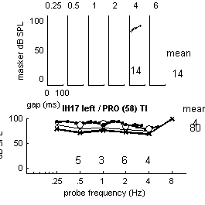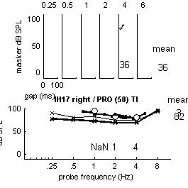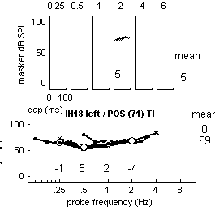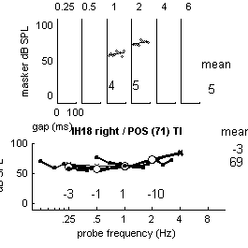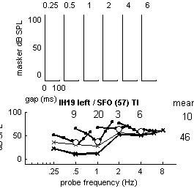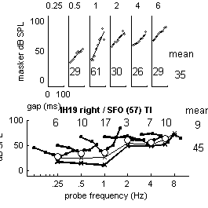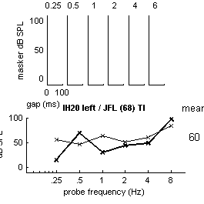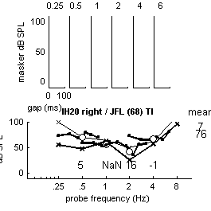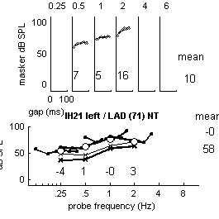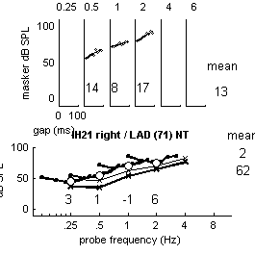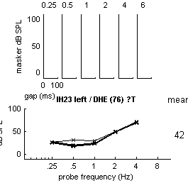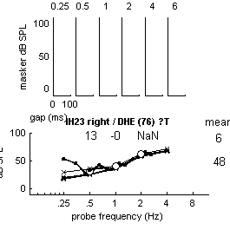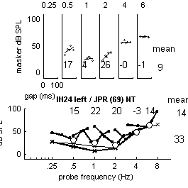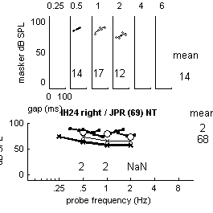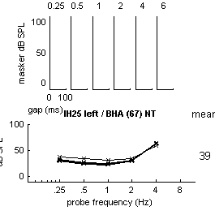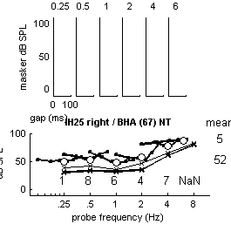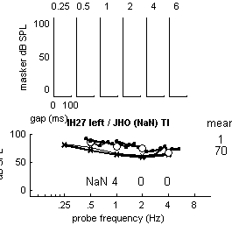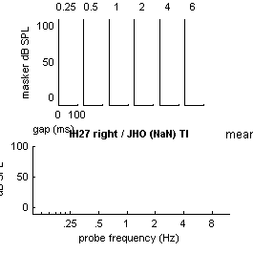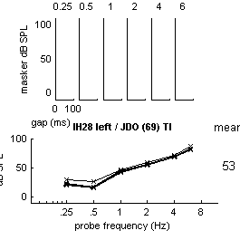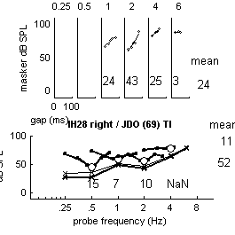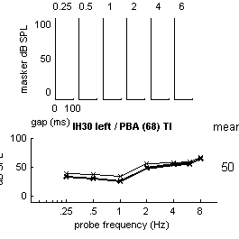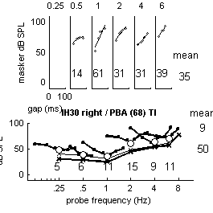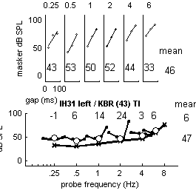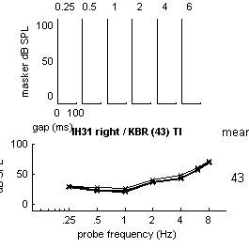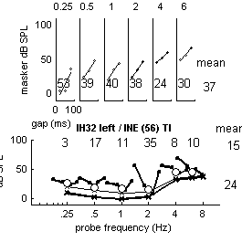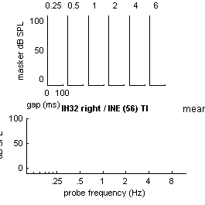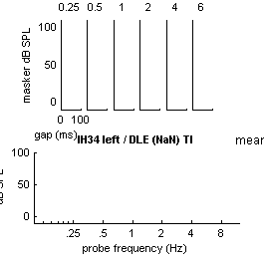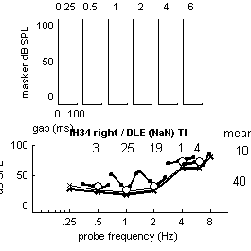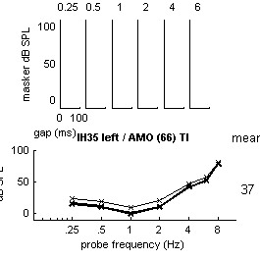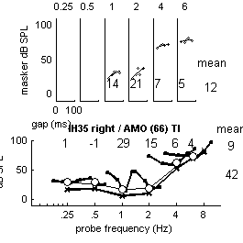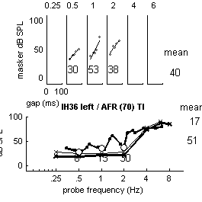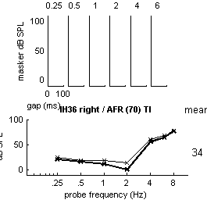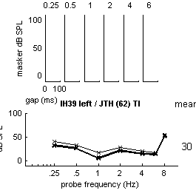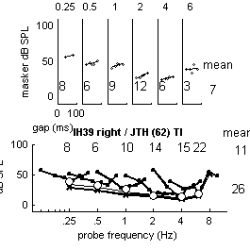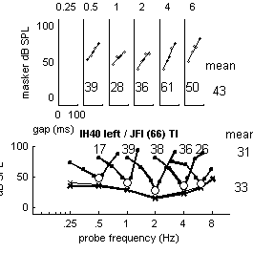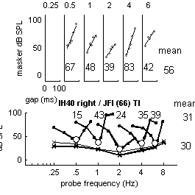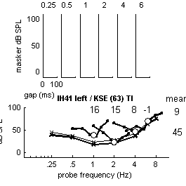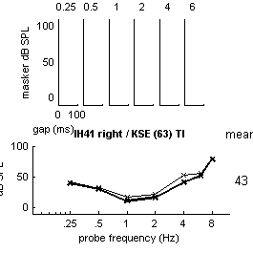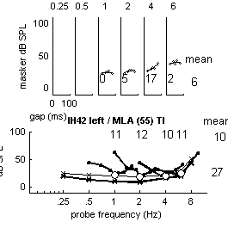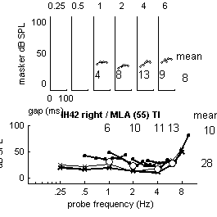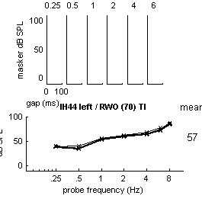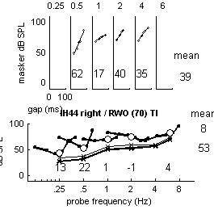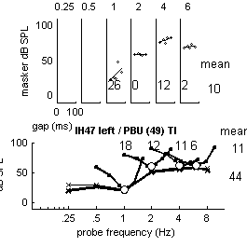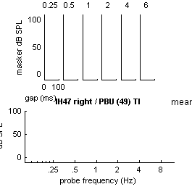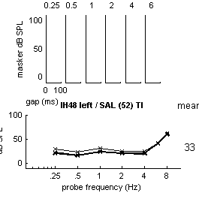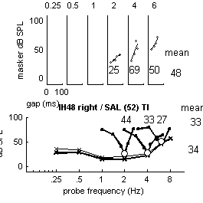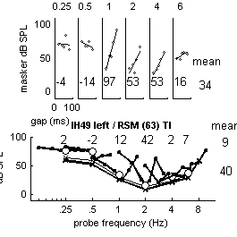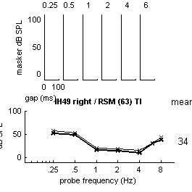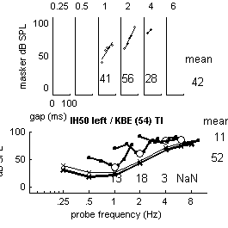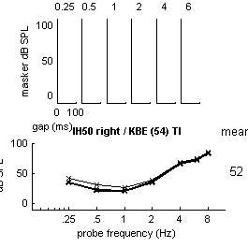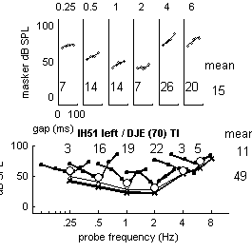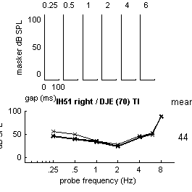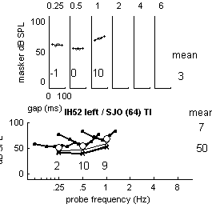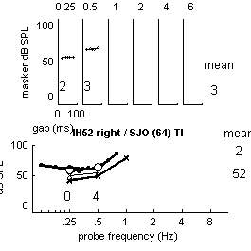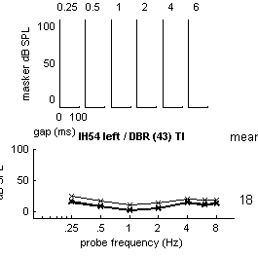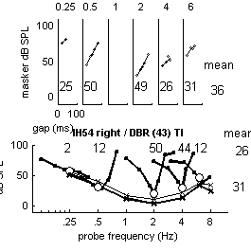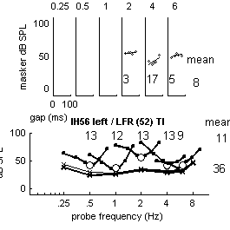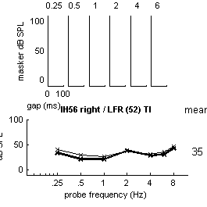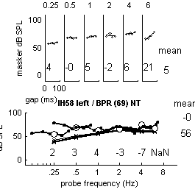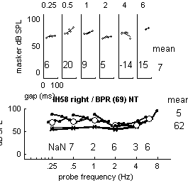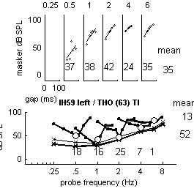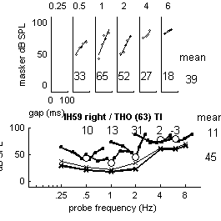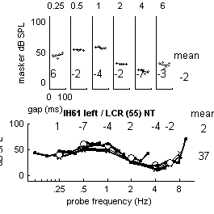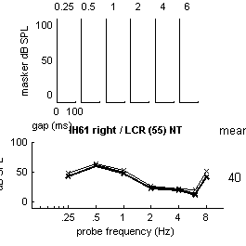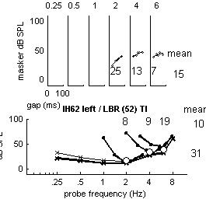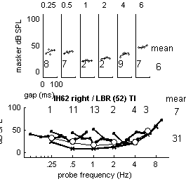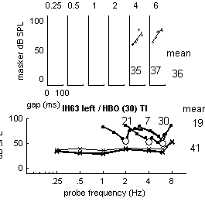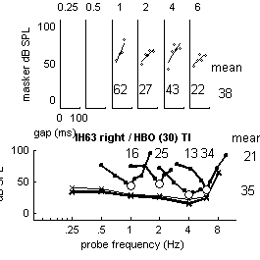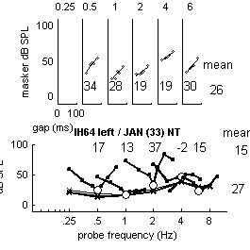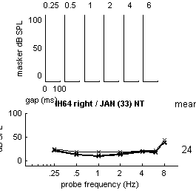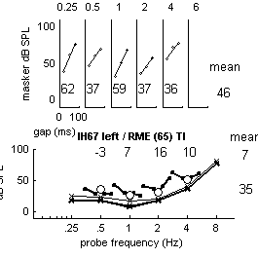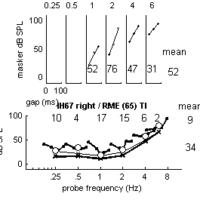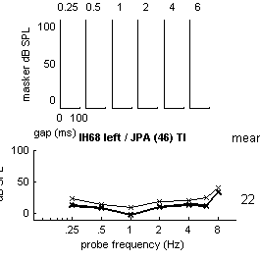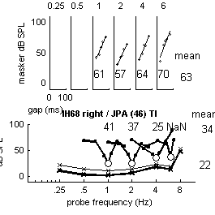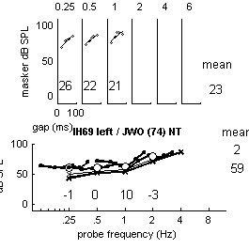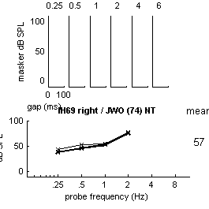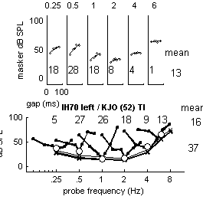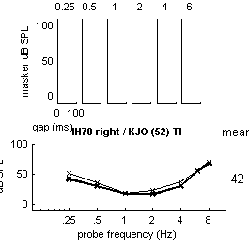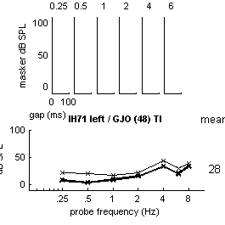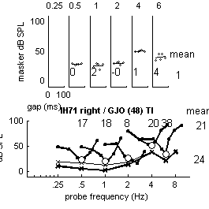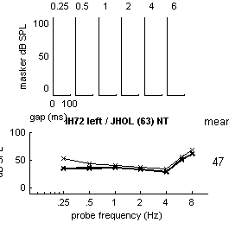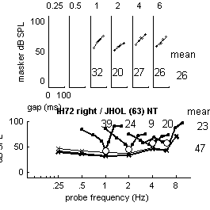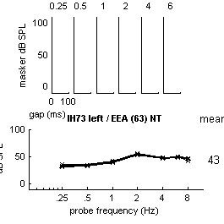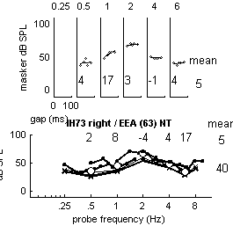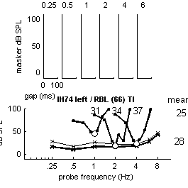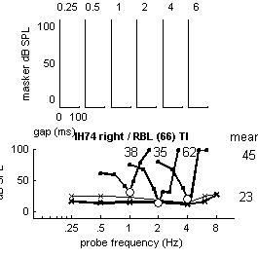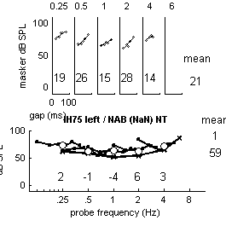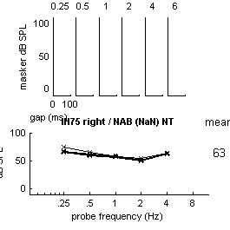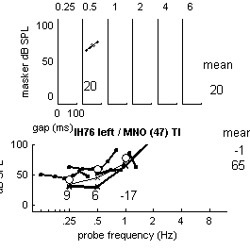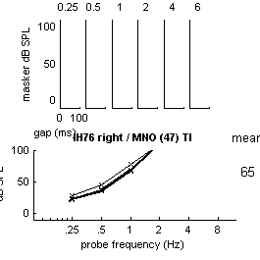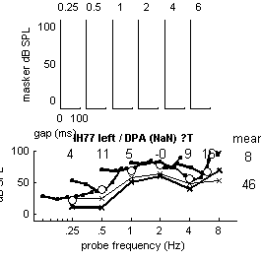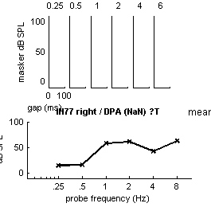
analyse accumulated data for this group & display average62participants
SS = IFMCsampleSize: [47 73 81 82 69 48 30]
absThrSampleSize: [119 119 118 114 108 73 85]
TMCsampleSize: [24 52 60 61 55 39 20]
meanLongTones: [1x7 double]
meanShortTones: [1x7 double]
stdevLongTones: [1x7 double]
stdevShortTones: [1x7 double]
stdevIFMCs: [7x7 double]
stdevTMCs: [7x9 double]
mean short vs long= 250 9.0 500 8.81000 6.52000 5.94000 4.36000 4.28000
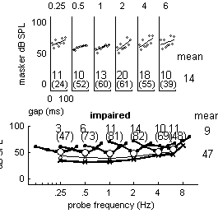

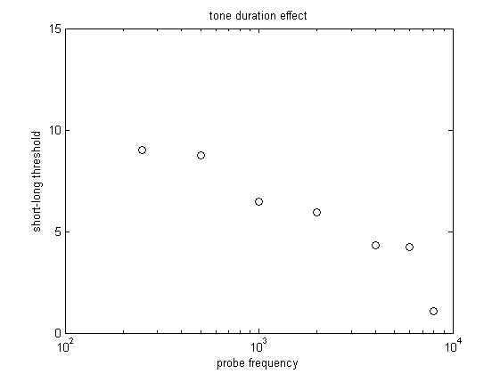
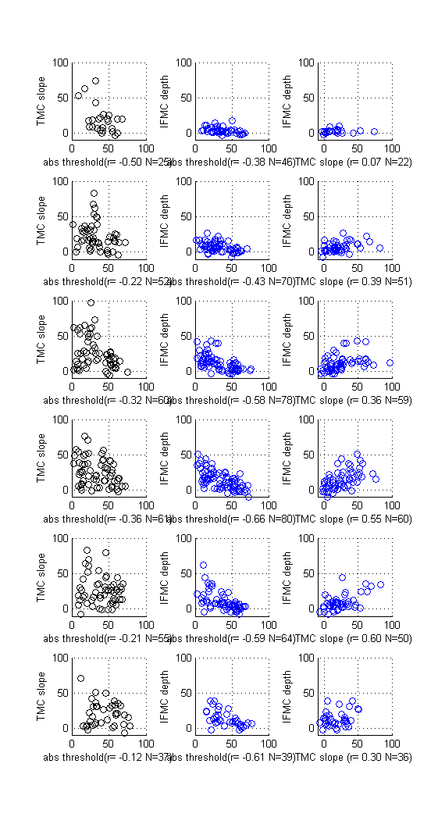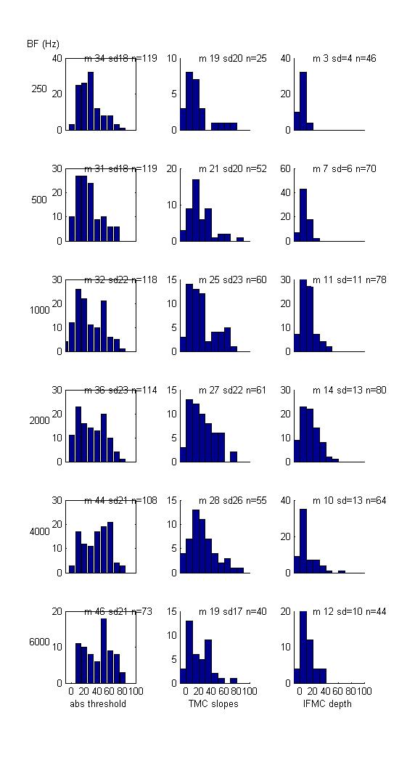
hist
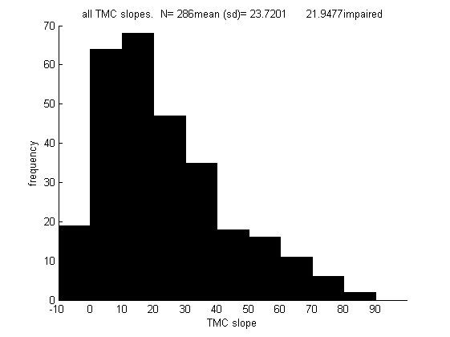

Compare left and right ears mean abs threshold difference= 0.46571 logical requirement= impaired
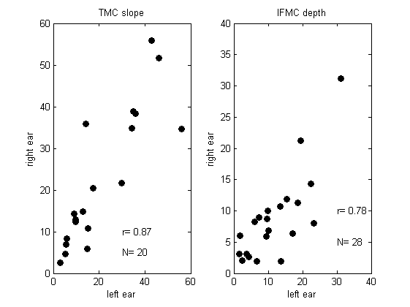

Double profiles

(normal and impaired)

All profiles are shown for cases where both left and right ear were studied in depth.

The purpose is to show similarities between the two ears and offer evidence of the reliability of the testing process.
Left ear right ear
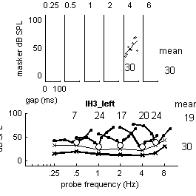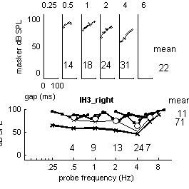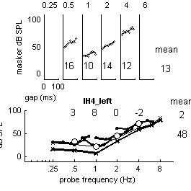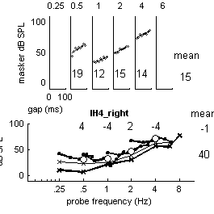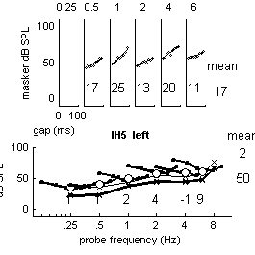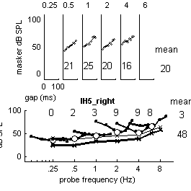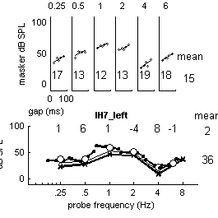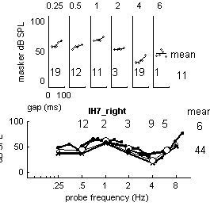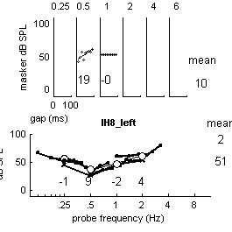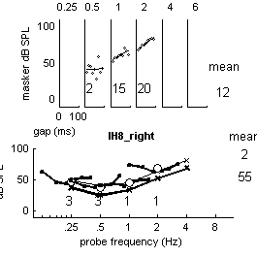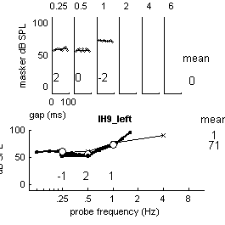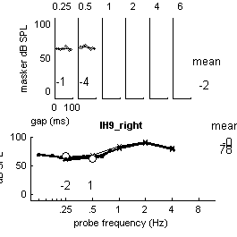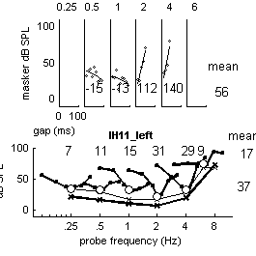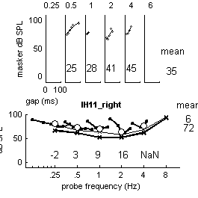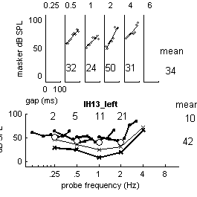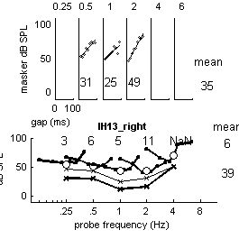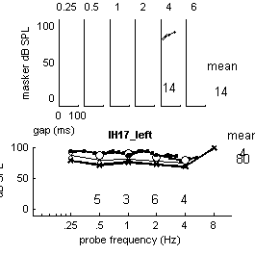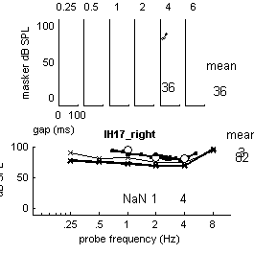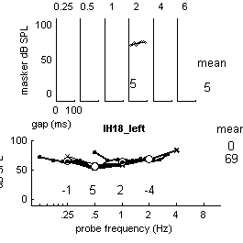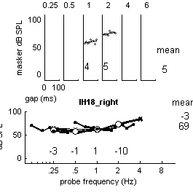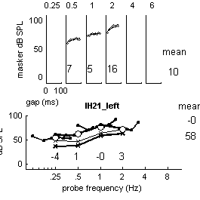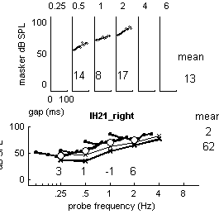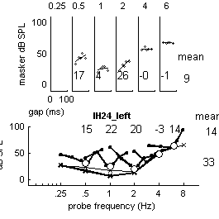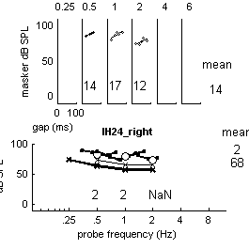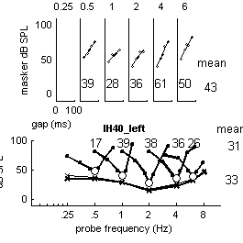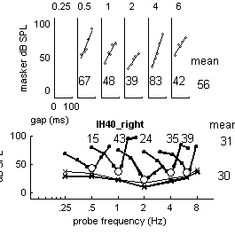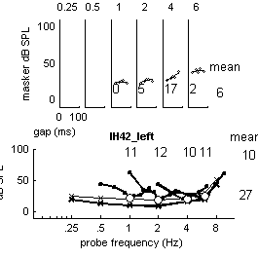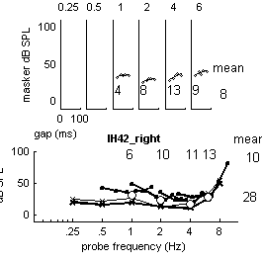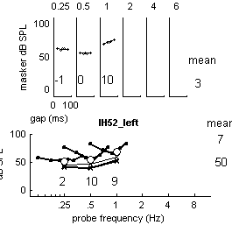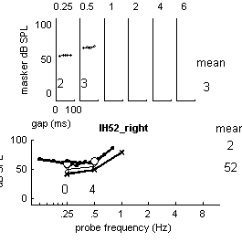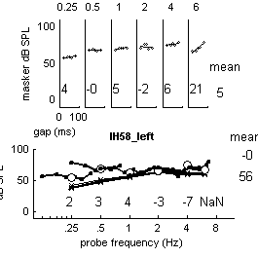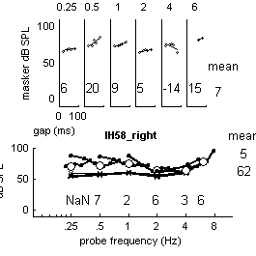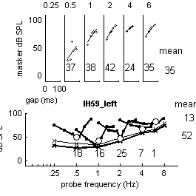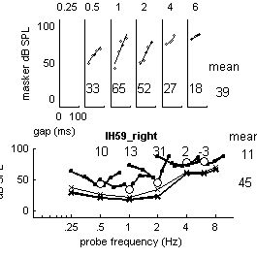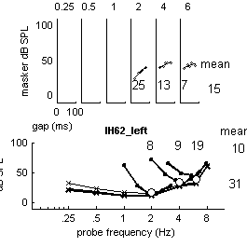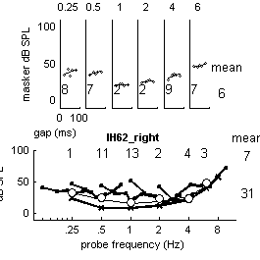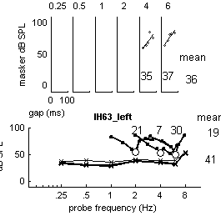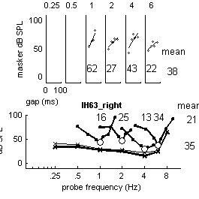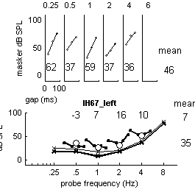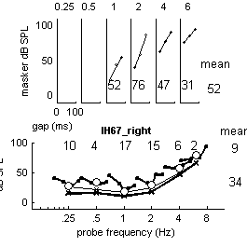
Excluding unilateral impairments

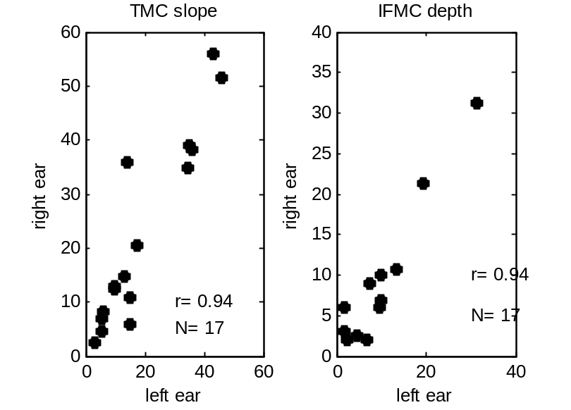

File format and programs

The files
The complete collection of individual profiles (one per ear per person) is held in a subfolder called allParticipants. Each profile is held in a separate .m file so that each participant has two files (left and right ear). If only one ear was studied, the other ear file exists but contains no data. When the .m file is run it creates and returns a structure containing all of the data.
The name of each data file consists of the word ‘profile_’, followed by the user’s code (e.g. ‘NH03’) and then and ‘_R’ or ‘_L’ according to which ear was tested; for example, profile_NH96_L is the left ear profile for participant #96 with normal hearing. Or profile_IH10_R for the left ear of participant #10 with impaired hearing. The participant number is unique.
These files are ‘raw data’ but even these are digests of more extended investigations. The data in the .m files are an attempt to introduce uniformity across participants in the presentation of available data. The original data is stored in Excel spreadsheets along with all of the testing details. These individual workbooks are available on request.
Participant details are held in an Excel file. The details include participant number, age, gender, year of testing and whether or not tinnitus is present. The Excel spreadsheet is called ParticipantList.xls.
These data (both the .m profiles and the participantDetails.xls) have been consolidated into a single data file, called participantCompendium.mat. This compendium file is described later. The management of individual profile.m files is described first.
Participants are normally tested for three things; absolute thresholds, temporal masking curves (TMCs) and iso-forward masking contours (IFMCs). These are intended to be measures of sensitivity, compression and frequency selectivity, respectively and are described more fully in the multiThreshold Quick reference and Users manual. Detailed testing protocols are described in Profiles summary.doc.

plotProfile
A single file can be plotted using the plotProfile.m program found in the profiles folder. For example, the call
plotProfile('allParticipants', 'profile_NH96_L')
plotProfile('allParticipants', 'profile_IH10_L')
will generate the two following images
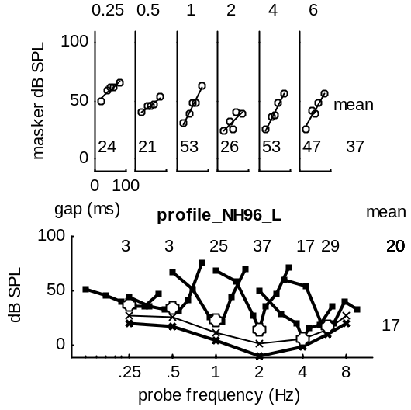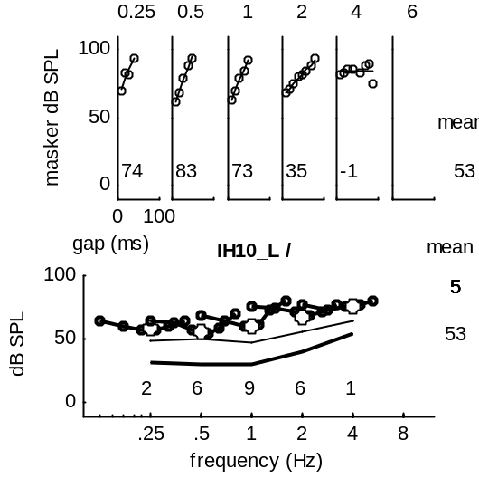
This function call has the following format:
plotProfile (<folder name>, <file name>, <comparison file name>, <figure number>)
The last two arguments are optional. The <comparison file name> refers to a second file in the same folder that is plotted as background (using faint, dashed lines). In the following example, a profile for someone with a high frequency loss is compared with a young person with good hearing. The final argument, <figureNumber>, is mainly for use by calling programs.
plotProfile('allParticipants', 'profile_IH10_L', 'profile_NH96_L')
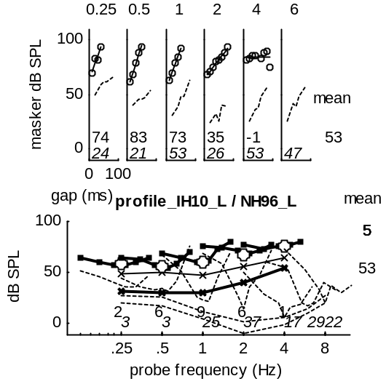
The visual profiles above show the results of attempts to quantify the shapes in the TMC and IFMC functions. The TMC measure is the slope of the best-fit straight line to the TMC data (in the top panels) expressed as dB/100ms. This is printed at the bottom of the upper panels. When two rows of figures are given, the upper row is the first (foreground) file. It can be seen that the good hearing profile has steeper slopes than the impaired profile but only at higher frequencies.
Our crude measure of frequency selectivity is quantified by the ‘depth’ of the V-shapes in the lower panel. This is computed as the average of the masker level at 0.7 and 1.3 times the probe frequency minus the masker level at the probe frequency (see diagram below). This simple metric gives large values when the IFMC is narrow and symmetric. These metrics are meant to be interpreted by comparison with values obtained from participants with good hearing. In the example above the good hearing profile has greater depth from 1000 Hz upwards.
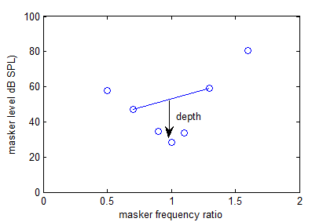
The numbers to the right of the plots are the averages across frequency for the first-named profile. The lowest figure to the right of the lower panel is the average absolute threshold for a long, 250-ms tone.

plotAllFiles
plotAllFiles.m is another program in the profiles folder. This will sequentially and rapidly plot all profiles of a particular type followed by summary statistics. For example,
plotAllFiles (‘impaired’)
will process and plot all profiles classified as ‘impaired’. At the end of the run an average profile will be computed. Summary statistics are then computed across all participants for whom relevant data is available.
Each plot appears in the same figure and they change quickly. The speed of the display can be controlled by adding a pause duration argument (in seconds),
plotAllFiles('~impaired', 1)
This will slow down the display considerably. This particular instruction will display only files with normal hearing. This is because impaired is a logical variable so ~impaired refers to all files that are not impaired. The first argument is a string containing a logical condition evaluated by the program when selecting from the data in the participantCompendium. The condition possibilities are as follows:
number double (unique subject identifier)
impaired logical
initials string
male logical
tinnitus logical
birthYear double
startTest double (year of testing)
age double (age when tested)
code string (eg ‘NH03’)
Examples
plotAllFiles('impaired & ~tinnitus', .1)
will plot all impaired files where tinnitus was known not to be present
plotAllFiles('impaired & age>65', .1)
will plot all impaired profiles for those over 65 years of age.
Statistical summaries.
At the end of a run, an average profile is computed and plotted. For example,
plotAllFiles('impaired & age>65',.1)
will generate the following average profile
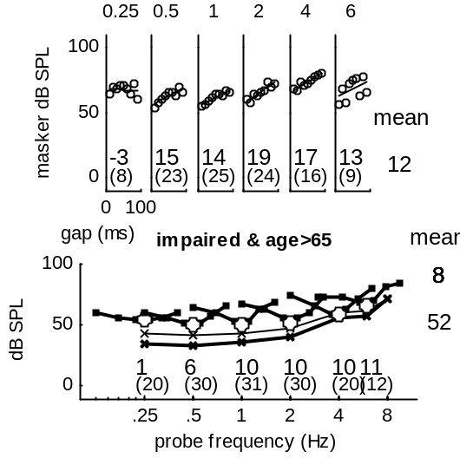
The figures in brackets are the number of ears that contributed to the average. This is important because it is not always possible to measure some values.
Two analysis figures are offered. The first shows the distribution of scores on three variables; absolute threshold, TMC slope and IFMC depth. These are subdivided according to the frequency tested. At the top of each subplot, summary statistics are shown; mean, standard deviation and sample size. Note that the analysis applies only to the profiles that were selected (in this case participants with impaired hearing aged over 65 years)
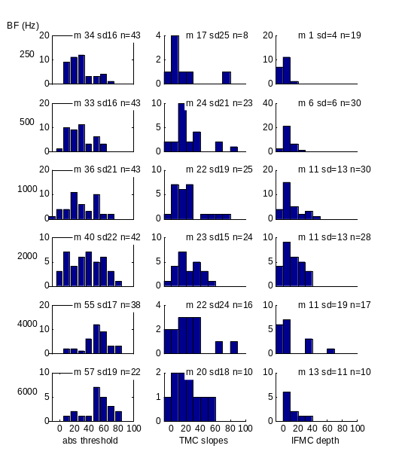
The second analysis shows scatter plots and correlations for each combination of these three measures. Again the analysis is performed separately for each probe frequency.
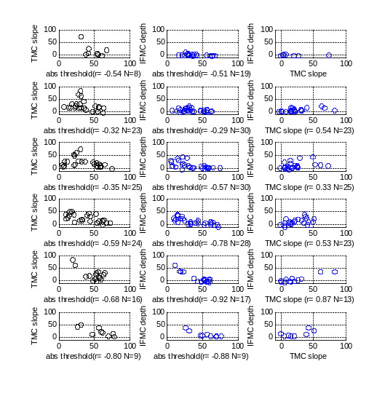
Left/ right comparison
When a participant has data from both ears, they are included in a special scatter diagram plotting left ear average statistics against the right ear. This example uses all impaired profiles but excludes all participants with unilateral impairments.
Paper copy (publish)
When this program is used in conjunction with MATLABs ‘publish’ facility, it can generate a .doc file for further scrutiny. This will create a document containing each profile chart as well as the summary statistics. The condition (e.g. ‘impaired’) needs to be set inside the plotAllFiles code. You will see that a special area of code near the top of the program helps you to do that.
The name of the document file cannot be set in the publish command. By default it will be called ‘plotAllFiles.doc’. Rename the document file immediately after the run. This sequence pasted into the command line will create the document file in a folder called ‘publishFiles’
options.outputDir='publishFiles';
options.format='doc'
options.showCode=false;
publish('plotAllFiles', options)

compareTwoProfileFolders
The following function uses plotAllFiles twice to compare the files in two different folders. In this example all profiles from participants with normal hearing are grouped in a folder called ‘normalHearing’. The remainder are grouped in a folder called ‘impaired hearing.
compareTwoProfileFolders('normalHearing', 'impairedHearing')
This will have the same effect as scanAllFolders applied separately but also produces a summary figure that compares the two groups on the basis of the three measures. The error bars are standard deviations, showing the spread of the original scores.
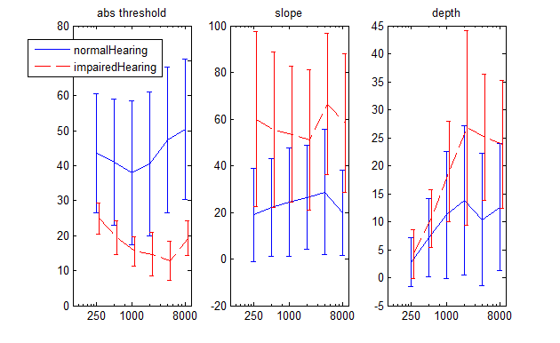
From this figure we can see that
- the absolute thresholds do not overlap between the groups
- the slopes of the TMCs do overlap considerably
- the TMC functions are shallower for the impaired group
- the TMC slopes do not change much with frequency
- the IFMC depth estimates are different between the two groups only at frequencies above 1000 Hz and, even then, there is considerable overlap even at these frequencies.

ParticipantCompendium
A .mat file called participantCompendium.mat contains a structure consisting of all the participants along with other biographical information as well as the data for both the left and right ear. Navigate to the profiles folder and type in the command window
load participantCompendium

This loads a single structure:
participant =

1x103 struct array with fields:
number
impaired
initials
matScript (exists)
iffy (problems with this listener’s data)
leftEar (exists)
rightEar (exists)
male
tinnitus
birthYear
startTest
age
code
leftEarData (data structure)
rightEarData (data structure)

This structure was compiled from data found in the participantDetails Excel files and all of the individual data files (see above).

Profile format
The individual profiles begin life as .m files that pass a structure back to the calling program. A profile represents a single profile for a single ear. Two profile files are supplied, one for each ear, even if only one ear is measured.

The format is shown here only for the benefit of those who wish to create new profiles. The information is derived from the output of the multiThreshold software. At present, there is no automatic logging of the output in this format. The transcription needs to be performed manually. A fixed format is used and missing data are presented as NaN (not a number).

function x = profile_BCR_R

x.BFs= [250 500 1000 2000 4000 6000 8000]; % abs threshold tone frequencies
x.LongTone= [10.5 6.9 21.3 30.1 56.4 55.7 77.0]; % thresholds (dB SPL)
x.ShortTone=[26.1 23.7 24.5 38.5 62.3 64.3 NaN];

x.IFMCFreq= [ ...
250 500 1000 2000 4000 6000 8000]; % IFMC probe frequency
x.IFMCs=[
NaN 41.38 40.50 44.14 66.92 NaN NaN
NaN 34.92 27.38 38.93 63.07 NaN NaN
NaN 31.17 32.05 43.87 66.58 NaN NaN
NaN 31.41 32.67 46.04 71.00 NaN NaN
NaN 39.61 18.04 49.21 71.86 NaN NaN
NaN 36.07 30.40 56.52 70.17 NaN NaN
NaN NaN 45.50 59.14 63.16 NaN NaN
]; % IFMC masker levels at masked threshold

x.MaskerRatio=[ 0.5 0.7 0.9 1 1.1 1.3 1.6 ]; % masker frequencies (relative to probe frequency)
x.IFMCs= x.IFMCs'; % NB transpose

x.Gaps= [0.01 0.02 0.03 0.04 0.05 0.06 0.07 0.08 0.09]; % gaps
x.TMCFreq= [...
250 500 1000 2000 4000 6000 8000]; % TMC probe frequencies
x.TMC= [
NaN 44.09 34.07 49.06 73.70 NaN NaN
NaN 51.61 33.27 49.83 75.05 NaN NaN
NaN 57.10 35.62 50.78 79.35 NaN NaN
NaN 54.77 34.13 55.46 77.98 NaN NaN
NaN 58.47 40.27 54.48 79.94 NaN NaN
NaN 57.27 37.92 56.56 80.86 NaN NaN
NaN 60.05 42.35 57.36 80.32 NaN NaN
NaN 63.49 39.96 59.52 84.33 NaN NaN
NaN 61.22 42.01 60.33 86.97 NaN NaN
]; % TMC masker levels at masked threshold
x.TMC = x.TMC'; % NB transpose

